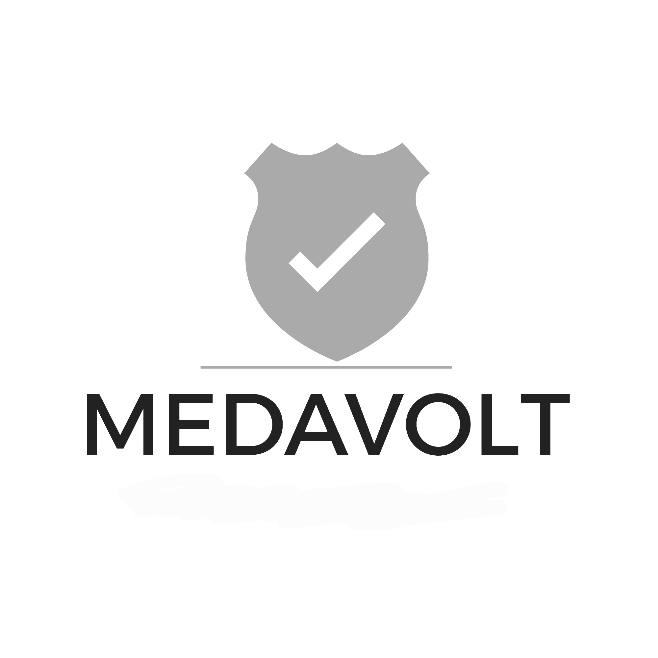
MEDAVOLT LLC
WATER & SEWER INFRASTRUCTURE CONTRACT STAFFING
Mission Statement • Capability Statement • Owner Profile

MISSION STATEMENT
"Service to our country doesn't end with the uniform. It continues in the infrastructure that keeps our communities safe, healthy, and running — and we're proud to carry that dedication into every contract we fulfill."
CAPABILITY STATEMENT

CORE COMPETENCIES
→ Water and sewer infrastructure construction staffing — pre-vetted personnel for utility line, treatment, and related structures work
→ Government construction contract staffing — project management, skilled trades, site supervision, and general labor
→ Pre-award personnel sourcing and qualification, matched to each contract's specific labor categories
→ Program and technical oversight of deployed crews for the duration of contract performance
→ CONUS and OCONUS deployment support

DIFFERENTIATORS
→ Personnel identified, qualified, and committed before proposal submission — reducing the government's staffing risk at the point of evaluation
→ OSHA confined space entry certification and applicable state water/wastewater credentials verified as standard screening criteria
→ Owner-operator background in handling Top Secret government information and certified in the secure management of sensitive information
→ Service-Disabled Veteran-Owned Small Business (SDVOSB) — direct access to VA Veterans First and federal SDVOSB set-asides
→ Veteran-owned and veteran-led: a continuation of service, not a departure from it

PAST PERFORMANCE
Update as contracts are awarded: [currently pre-award; capability demonstrated through certifications and personnel pipeline development]

COMPANY DATA
Legal Name | MedaVolt LLC
Entity Type | Wyoming Limited Liability Company
Business Address | 1309 Coffeen Avenue STE 17705, Sheridan, Wyoming 82801
Phone | (844) 633-2865
UEI | GSG5AJN62UM5
CAGE Code | [CAGE Code — from SAM.gov]
Primary NAICS | 237110 — Water and Sewer Line and Related Structures Construction
Secondary NAICS | 236220, 237990, 561320
Certifications | Service-Disabled Veteran-Owned Small Business (SDVOSB)
State Contractor License | [State(s) and license number(s)]
Bonding Capacity | [Aggregate / per-project bonding capacity]
Point of Contact | Jordan Michael Miles — contact@medavolt.us — (844) 633-2865

ABOUT THE OWNER
Full name: Jordan Michael Miles
Jordan founded MedaVolt after a career built around a single discipline: managing sensitive information and personnel with precision and accountability. With a background handling Top Secret government information and certified in the secure management of sensitive information, Jordan brings direct experience with the standards government infrastructure work demands.
As a veteran, Jordan built MedaVolt on a simple conviction: that service to the country doesn't end when the uniform comes off. It continues — in the infrastructure that keeps water safe and communities running, and in the opportunity to bring other veterans into meaningful work that carries that same mission forward. As a Service-Disabled Veteran-Owned Small Business, MedaVolt is built with a hiring approach that prioritizes veteran talent, extending the same dedication to service that shaped Jordan's own path.

